

HSBC Payments - Dynamics GP interface

Installation guide

For

**PROENERGY**

Project

**HSBC Payments - Dynamics GP interface**

By

**Lina Toro**

**TiiSelam**

**Log of changes**

|  |  |  |  |
| --- | --- | --- | --- |
| **Fecha** | **Autor** | **Versión** | **Referencia** |
| 07/07/2017 | Lina Toro | 1.0 | Elaboración |
|  |  |  |  |
|  |  |  |  |

**Customer review**

|  |  |  |  |
| --- | --- | --- | --- |
| **Nombre** | **Versión** | **Rol** | **Fecha** |
|  |  |  |  |
|  |  |  |  |
|  |  |  |  |

HSBC Payments - Dynamics GP interface

# Introduction

Proenegy Argentina requires a payment interface to suppliers through HSBC's electronic banking platform.

This is a guide for installing this functionality on Dynamics GP.

# Installation

|  |  |
| --- | --- |
|  | |
| **ID:** | **pbe** |
|  |  |
| Description: | Chunk and sql scripts installation |
| Pre-conditions: | The user must have copy, read, modify, and delete permissions on the folder and subfolders of Microsoft Dynamic GP |
| Steps: | 1. Copy the PBEGP.cnk chunk into the folder where the GP executable is located 2. Execute GP as Admin 3. A screen will be displayed indicating that a new code will be installed. Choose YES. 4. Enter GP with the user sa or Dynsa, the first time to create the necessary tables and GP procedures 5. In GP, use the sql maintenance option to create the sql objects of the product PBEGP      1. Give security permissions to users to access windows / tables and development reports. 2. Open SQL server management studio and execute the sql scripts in the Proenergy test company. Execute the scripts in order. |
|  |  |

# Security

|  |  |
| --- | --- |
|  | |
| **ID:** | **pbe** |
|  |  |
| Description: | Give users access to functionality |
| Pre-conditions: | Enter into GP as a power user |
| Steps: | 1. Create a security task 2. Add the following Windows to the task:      1. Add the following files to the security task:      1. Assign the task to a role, and the role to a profile 2. Assign the profile to a user   Proenergy: Tii Acct Manager role |

# Configuration

1. On Configuración / compañía / configuración de medios de cobro-pago/secuencia de numeración, setup the code: HSBC. For example:

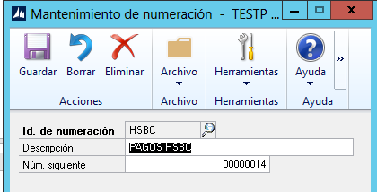

1. On Configuración / compañía / configuración de medios de cobro-pago/Tipos de ingreso/desembolso, setup the following types:

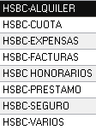

Also, use the code HSBC (created in the previous step) in the field Id. De numeración.

For example:

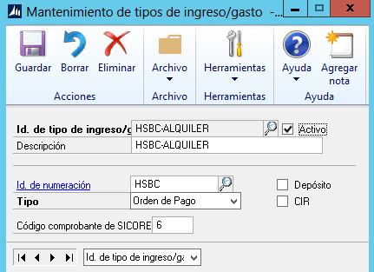

1. On Configuración / compañía / configuración de medios de cobro-pago/Grupo de cobro-pago, setup the following groups: CHEQUED, CHEQUEN, TRANSFERENCIA. For example:

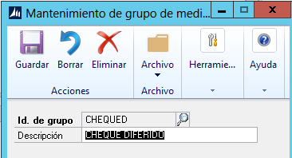

1. On Configuración / compañía / configuración de medios de cobro-pago/medios de cobro-pago, assign any of the following groups: CHEQUED, CHEQUEN or TRANSFERENCIA, to the corresponding means of payment:

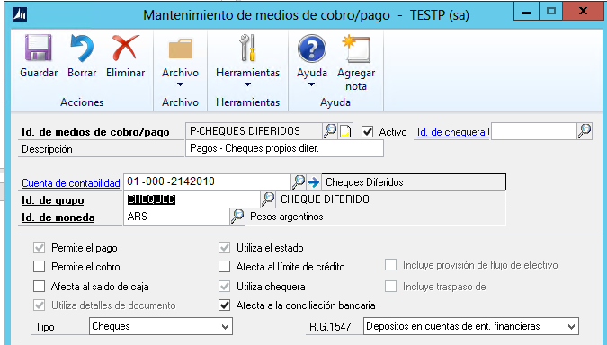

1. On Configuración / compañía / configurar exportación de Sicore / configuración de código de impuesto, create the tax Id. PIB. For example:

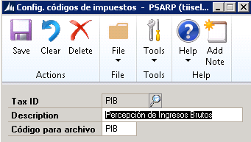

1. On Configuración / compañía / configurar exportación de Sicore / configuración de códigos de régimen, créate the following Ids: 901, 902. In the field Descripción, enter the province jurisdiction

For example:

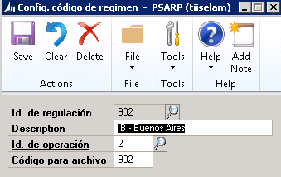

1. On Configuración / compañía / configuración de medios de cobro-pago/Detalles de retención select an **IIBB** or SUSS taxes.
2. In the field Descripción, insert the DGR resolution number and a dash to separate it from the real description.
3. In the field Tipo de Id, insert one of the following values:
   1. GCIA – Retención de ganancia
   2. IIBB – Retención de Ingresos Brutos
   3. IVA – Retención de IVA
   4. SUSS – Retención de SUSS
4. Click in the field Régimen. The window Retenciones – impuesto/regimen opens.

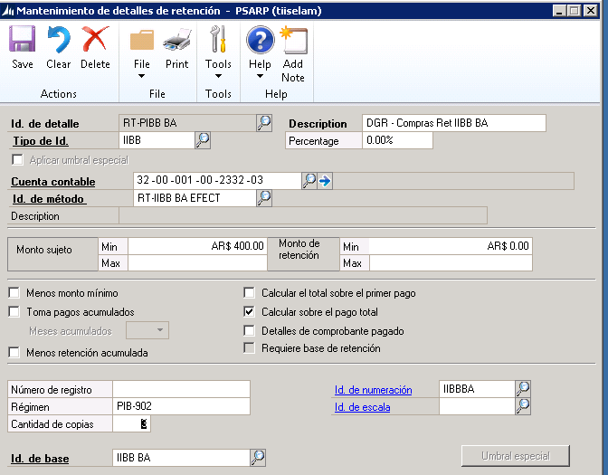

10

8

9

7

1. On the window Retenciones – impuesto/regimen, enter the Id IIBB in the field Id. De impuesto.
2. On the window Retenciones – impuesto/regimen, enter the Id 9xx (according to the province jurisdiction) in the field Id. De regulación.

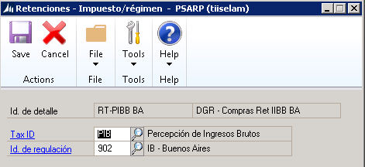

12

11